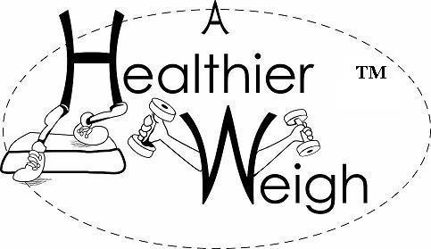
A Healthier Weigh in 2026

“A Healthier Weigh” is a 12-week program to promote health and fitness.
Participants will be Teams or Individual adults (18 and older).
Registration Fee is $40 per person; $80 per team of two; $160 per team of four.

Members will encourage each other to increase walking and other physical activity; complete lessons about nutrition, health and fitness; and stay focused throughout the 12 weeks.

- Team of 4 adults or 2 adults or Individual - complete the Entry Form. Choose a fun, funny, or funky team name. Team names (not individual names) are used in publicity during the challenge. Team members will be identified with award publicity at conclusion of challenge.
⮚ Entries and payment are due to your local Extension Office at weigh-in.
- Weigh-In: Participants’ weight and waist circumference will be measured to be used as a tool to show progress. Contact the Extension Office for scheduling.
- Participants will receive a pre and post challenge InBody - Body Composition Analysis scan to provide details of lean body mass, body fat mass, water/hydration, & BMR.
- To support participants with researched based nutrition and fitness information, on-line lessons are provided by Extension during the duration of the challenge. In order to be eligible for prizes at the end of the challenge, ALL participants are required to complete at least 5 of the lessons.
- Logan, Morgan, and Yuma County A Healthier Weigh officially starts Monday, January 13th.
- Members record daily activity and report weekly to the Team Captain, who reports individual and total team steps for the week via the online step reporter or email. Individual participants report activity directly to the Extension Office again through the online step reporter or email. Step activity may be tracked using a cell phone tracking app, wearable fitness tracker (Fitbit, Apple watch, Garmin, etc.), or a traditional pedometer. Pocket pedometers will be available from CSU Extension staff while supplies last. A conversion sheet will be provided for other fitness activities.
- Weigh-out: A Healthier Weigh ends Sunday, April 6th^{t}. for Logan, Morgan, and Yuma counties and April 13th for Kit Carson, Phillips, and Washington counties. Participants will come in for final weight and waist measurements and complete the Post-Survey during the week following their end date.
⮚ If you are under a physician's care for any health condition that may affect your ability to participate in this program, we recommend approval from the physician before beginning.
- If you have a disability for which you seek an accommodation, please notify Extension staff by January 3, 2025.

We hope you will enjoy “A Healthier Weigh.”
Copyright December 2025, Colorado State University Extension.

Colorado State University Extension is an equal opportunity provider. | Colorado State University does not discriminate on the basis of disability and is committed to providing reasonable accommodations. | CSU’s Office of Engagement and Extension ensures meaningful access and equal opportunities to participate to individuals whose first language is not English.

Colorado State University Extension es un proveedor que ofrece igualdad de oportunidades. | Colorado State University no discrimina por motivos de discapacidad y se compromete a proporcionar adaptaciones razonables. | Office of Engagement and Extension de CSU garantiza acceso significativo e igualdad de oportunidades para participar a las personas quienes su primer idioma no es el inglés.

