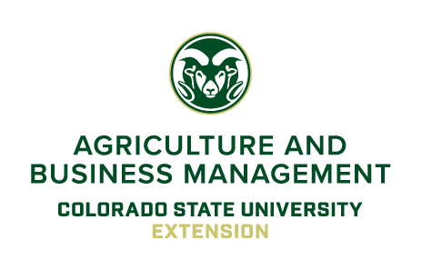 |  | Colorado State University Extension  Northeast Regional Engagement Center  Contact: R. Brent Young  Title: Regional Extension Specialist  ph.: 970-522-7207  e-mail: brent.young@colostate.edu
For Immediate Release November 6, 2020
The 3R’s of Loan Renewal Webinar Series
Be Ready! Be Real! Be Responsible!

(Sterling, Colo.)

Thanksgiving is just a few weeks away and the start of the 2020 Holiday season. Many agricultural producers are also planning for the loan renewal season. In an effort to help farmers and ranchers prepare and secure financing for the 2021 growing season, the CSU Extension Ag Business Management (ABM) Team is offering the 3R’s of Loan Renewal webinar series.

The 3R’s of Loan Renewal webinar series is meant to assist farmers and ranchers in the development of balance sheets, income statements, and statement of cash flows. Producers will also learn how lenders evaluate your financial statements and use them in the renewal process. Participants will be introduced to several decision aids developed by the ABM Team that will assist them in preparing the documents necessary for completing the loan renewal process.

This 4 part webinar series consists of 3 "Virtual Owners Manual Sessions" that cover income statements, balance sheets, and statement of cash flows. These sessions will be pre-recorded, 30 minutes in length, and available after November 20th for you to view at your convenience.
A final "Virtual Coffee Shop Session" will be offered live via Zoom on Tuesday, December 8th from 6:30 to 8:30pm. After completing the recorded sessions, we will meet live to answer questions, discuss options, and help develop a plan for loan renewal season.

One fee of $35 covers all four sessions. To register online go to https://3RS.eventbrite.com. For more information contact Brent Young at 970-522-7207 or email at brent.young@colostate.edu

